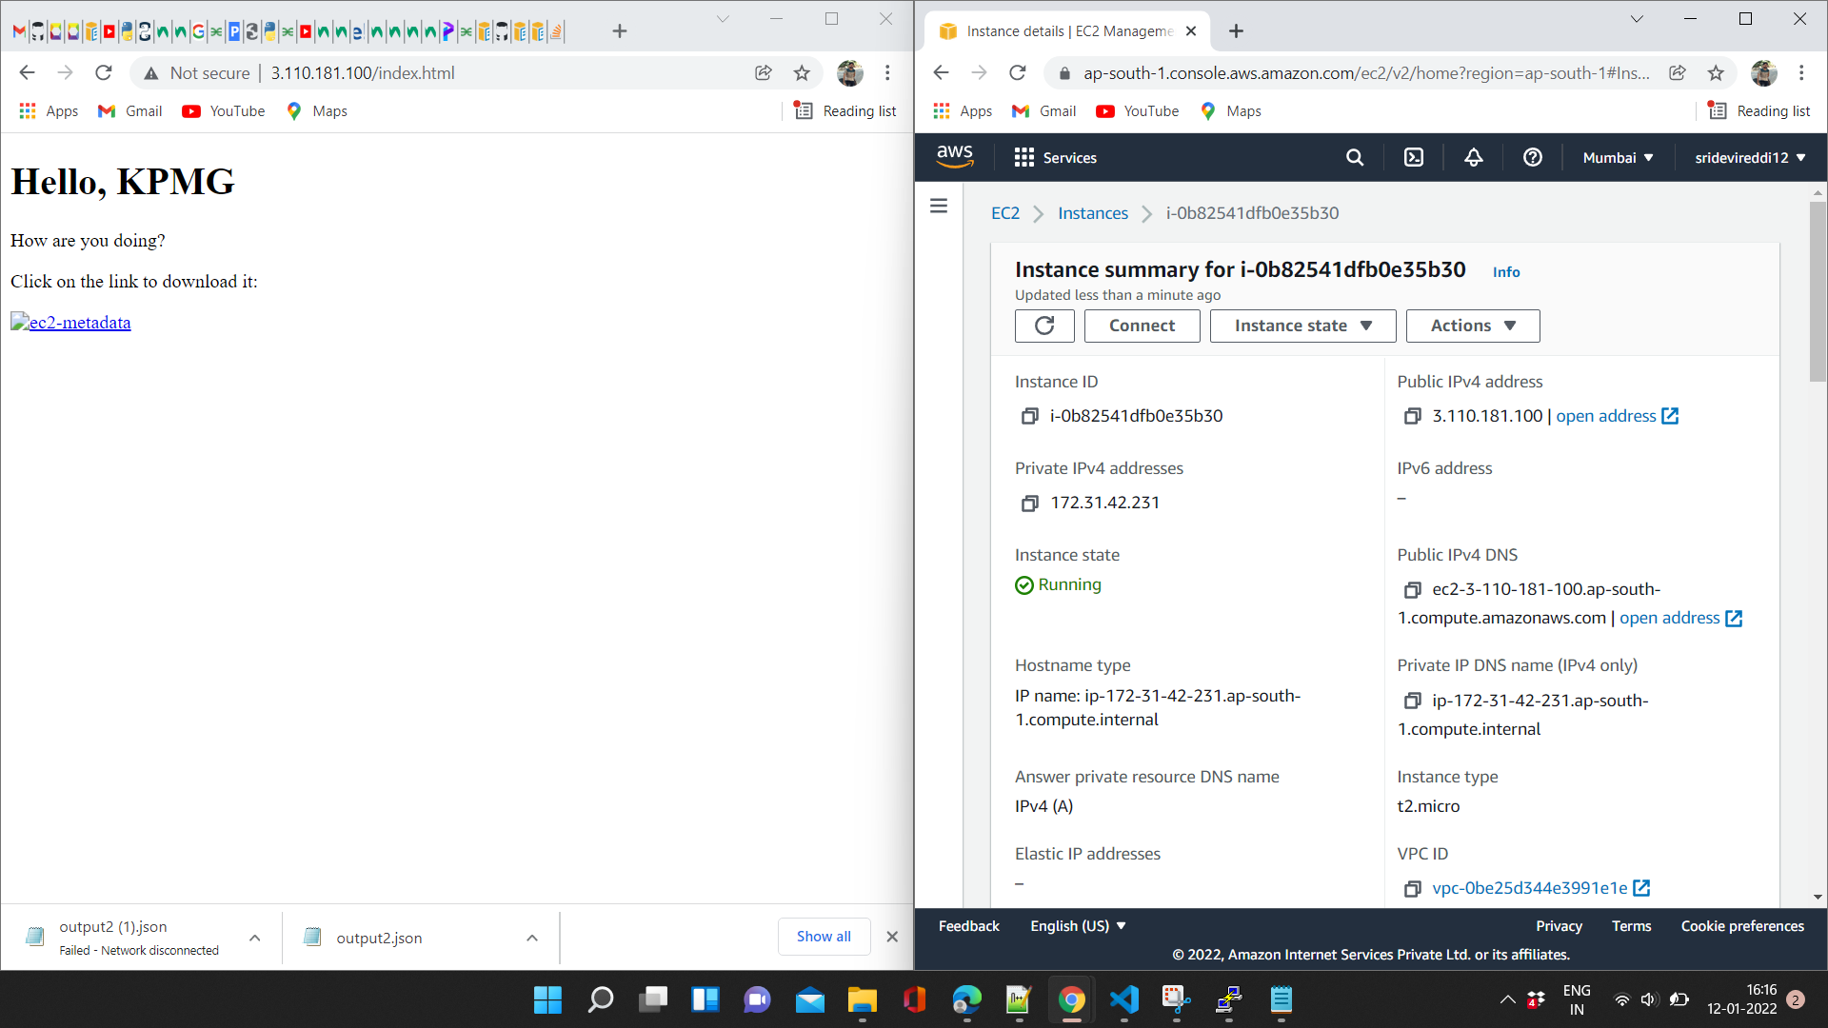

Installed apache server on the AWS ec 2 instace

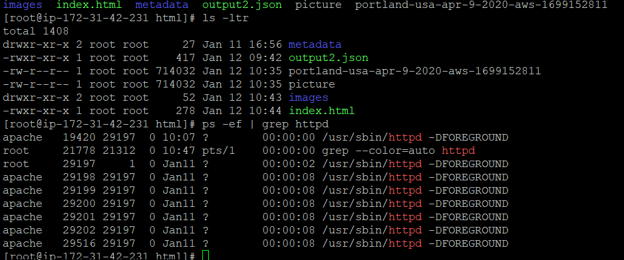

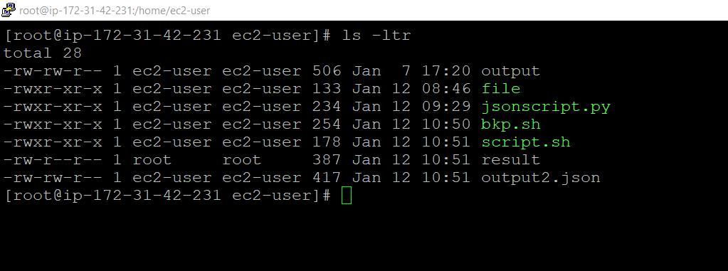

The shell script reads the variables from the “file” and saves the output to the “result file”.And then python script jsonscript.py will read the keys and values and convert the data into json formate

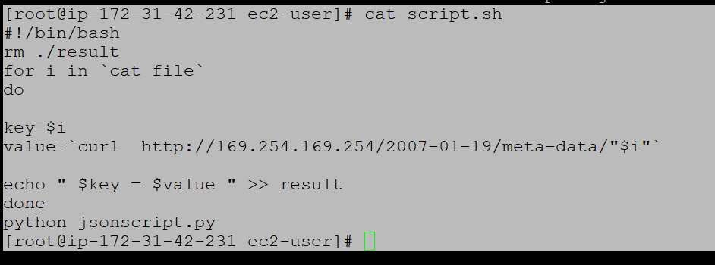

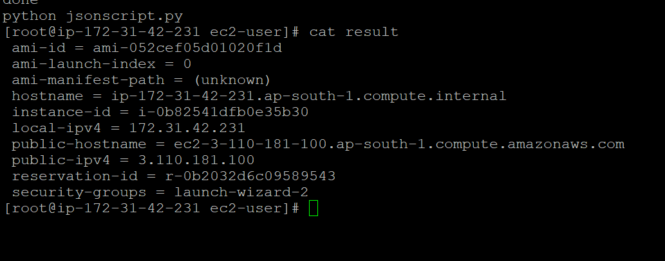

Python script generates a json file named output2.json.

Apache server can be used to download the json file from the webpage.



Download the file , open it in visual studio code . Right click on the content and click format data.

Raw data

{"hostname ": "ip-172-31-42-231.ap-south-1.compute.internal", "ami-launch-index ": "0", "public-hostname ": "ec2-3-110-181-100.ap-south-1.compute.amazonaws.com", "ami-id ": "ami-052cef05d01020f1d", "ami-manifest-path ": "(unknown)", "local-ipv4 ": "172.31.42.231", "reservation-id ": "r-0b2032d6c09589543", "security-groups ": "launch-wizard-2", "instance-id ": "i-0b82541dfb0e35b30", "public-ipv4 ": "3.110.181.100"}

Data opened in VS code looks as below

